**Framework Development**

What is automation framework:

Automation Framework is a **collection of files and tools** working together to support automated testing of any web application.

Organization or Intergration of all the automation files, libraries & other tools we need for automation testing in called **Automation framework development.**

For example – Test data file, Test cases, Utility files, Configuration file, Drivers, Test Reports etc.

**Advantage of framework :**

1. Maintainability
2. Reusability (Reusing resources)
3. Code shall be generic means the code should be compatible with more than one application.

**A good framework should support :**

1. Reusable methods
2. logging
3. low maintenance
4. reporting
5. test case mapping with manual test cases
6. data changes without compiling

**Steps to build Automation Framework :**

1. choose a programming language – java
2. choose a unit test framework – TestNG
3. design the framework architecture

* Page Object Model with page factory
* Maven (Automation Build Tools)
* Utilities for different generic functions ( read excel file ( test data file), listener class, read configuration file)

1. choose a reporting mechanism – Extent Report ( Dashboard ( Pass/Fail Test) by using Extent Report
2. Logging – Log4J2 (Logging API)
3. Choose a Version Control mechanism – Git & GitHub
4. Decide how to implement CI/CD – Jenkin

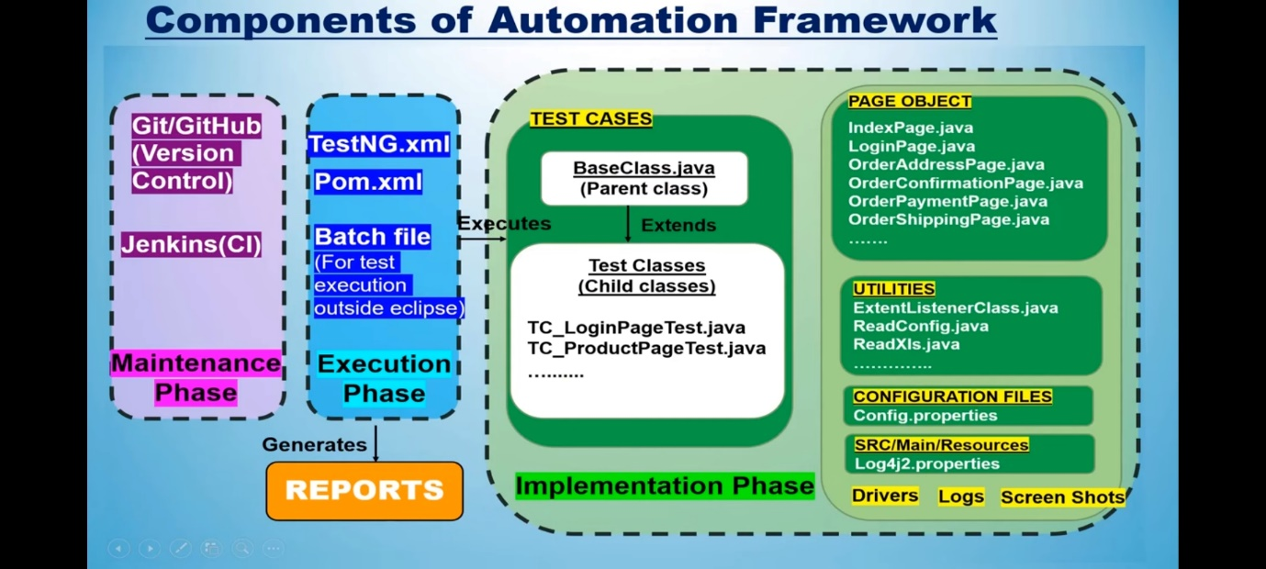

**Implementation :-**

1. create project structure using eclipse IDE
2. create Maven project

* PageObject package
* testcases package
* utilities package
* testcase folder
* configuration colder
* log folder
* screenshot folder
* driver folder ( for browser drivers)
* src/main/resource folder ( log4j2.properties file)

1. update pom.xml by adding dependencies for

* selenium webdriver
* WebdriverManager
* Log4J2
* TestNG
* Apache POI
* Extent report

**Maven** – maven searches the local repository to check if all the dependency present or not, if not, the libraries will be downloaded from online.

Note – Extent Report create krne ke liye ITestLinstner ka use krte hai or screen shot lene ke liye ontestfailure method m code likhenge extent report m add krne ke liye or base blass m screenshot ka code likhenge

session – 4

Running test case on different browser ,

DataDriven Testing – us9ng TestNG data provider with excel

1. Apache poi jars ( for handling excel file)
2. create excel file to store test data – MyStoreTestData.xlsx
3. ReadExcelFile (utility to read test data file)
4. @Data Provider

execution with POM.xml file –

add two plugin **(compiler plugin, surefire plugin)** between properties tag and dependences tag

- Refresh krenge project ko or update krenge update ke liye POM.xml pe right click krke maven pe jake update project krenge esse jo dependencies rh gyi sb add ho jayegni.